FOR IMMEDIATE RELEASE

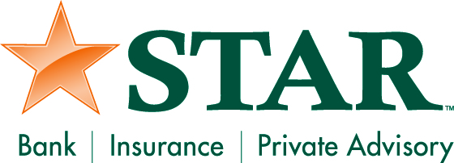

Contact: Kristin Marcuccilli
SVP, Chief Operating Officer
Phone: (260) 479-2622

Drop off letters to Santa at any of STAR Bank’s 15 northeast Indiana banking centers.

FORT WAYNE – STAR Bank has set up mailboxes for children to submit letters to Santa from now until Friday, December 13th.

“Letter to Santa” forms are available at the banking centers for children to complete. If needed, STAR employees will assist children in writing their letters to Santa before dropping them in a special mailbox set up at the banking center.

The children will receive a personalized letter back from Santa confirming receipt of their letter.

Children may submit their letters to Santa at any of the locations listed below during regular bank lobby hours through December 13th. Please visit www.starfinancial.com for each banking center’s lobby hours.

- Angola: 2004 N. Wayne St.
- Churubusco: 4070 N US 33
- Columbia City: 102 W. Van Buren St. (drive-up only) and 105 Frontage Road
- Fort Wayne: 5513 Illinois Road, 5920 St. Joe Center Road, 7110 Lima Road, 127 W. Berry St., 6240 Bluffton Road, 1820 N. Coliseum Blvd., 5760 Coventry Lane, and 2130 E. Dupont Rd.
- Hamilton: 7700 S. Wayne St.
- Kendallville: 360 W. North St.
- South Whitley: 207 S. State St.

###

Note: In all references to STAR, “STAR” should be in all caps.

STAR Financial Bank, headquartered in Fort Wayne, Indiana, is committed to delivering quality financial expertise and distinctive banking solutions to exceed customer needs. In addition, STAR Private Advisory offers private banking, investment and fiduciary services. STAR Insurance Agency is a full service insurance and annuity provider. STAR has grown to $1.6 billion in assets with 54 locations in central and northeast Indiana. For more information, visit the company’s web site at starfinancial.com.

