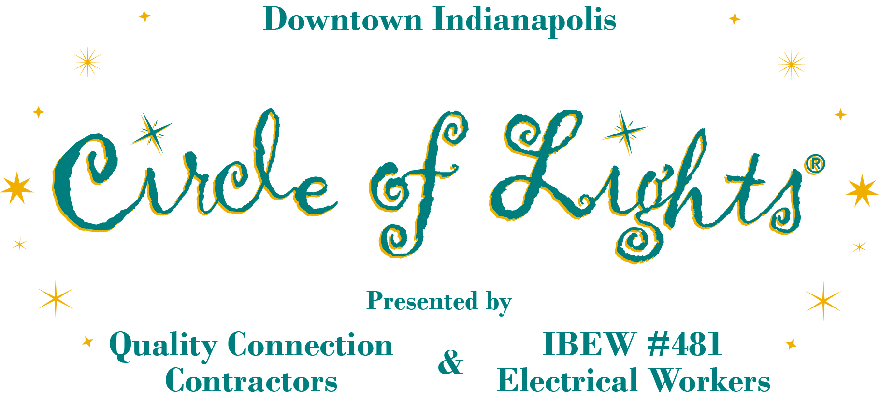

NEWS RELEASE For Immediate Release, 2013

Contact: Jennifer Hanson, 317.237.2202, Indianapolis Downtown, Inc., jhanson@indydt.com

Circle of Lights® presented by Quality Connection and IBEW #481:

a must-see holiday tradition!

100,000 spectators. 4,784 colored lights. 52 garland strands. 52 larger-than-life decorations. 51 years. One must-see holiday tradition!

For 51 years, thousands of spectators have gathered Downtown at Monument Circle to see the most spectacular holiday display illuminate. Indy’s most beloved holiday tradition is here again. Circle of Lights® presented by the Contractors of Quality Connection and Electrical Workers of IBEW #481 will take place the day after Thanksgiving, Nov. 29, 2013.

Generations of families are drawn to this beautiful centerpiece each year. The Indiana Soldiers and Sailors Monument will again be surrounded with 26 larger-than-life toy soldiers and sailors, along with 26 peppermint sticks. Additionally, 52 garland strands with 4,784 colored lights will be strung from the top of the Monument to its base.

More than 100,000 spectators are expected for the FREE Circle of Lights® presented by Quality Connection and IBEW #481 ceremonial lighting and holiday kickoff on Friday, Nov. 29. Entertainers chosen from statewide auditions will share the stage with Indianapolis native Sandi Patty and The von Trapp Family singers, both appearing at the Indianapolis Symphony Orchestra’s Duke Energy Yuletide Celebration. Festivities begin at 6 p.m. with the televised show running from 7 – 8 p.m. The Monument light-up will occur at approximately 7:45 p.m.

Each year, a lucky child is chosen from a coloring contest to help “flip the switch” with Santa and the Mayor. The show stage features a Santa’s Workshop theme complete with toy soldiers and sailors, peppermint sticks, ornaments, elves in the workshop and an abundance of toys. The stage centers around a countdown box.

Millions of sightseers will take in this brilliant spectacle throughout the holiday season, lit through Jan. 11. The decoration of Monument Circle is one of Central Indiana’s favorite holiday traditions! Travelocity named the Circle of Lights® one of the top five “must-see Christmas trees” in the nation.

“The Contractors of Quality Connection and Electrical Workers of IBEW #481 are thrilled to be the presenting partners of Circle of Lights,” said Sean Seyferth, IBEW #481 business manager. “The tradition is a wonderful opportunity to showcase the standards and craft of the union electrical construction industry along with our community commitment. We invite all Hoosiers to kick off their holiday celebration with us!”

-more-

As the presenting partners of Circle of Lights®, Quality Connection is a labor management partnership that represents more than 100 union electrical contractors and more than 3,000 International Brotherhood of Electrical Workers (IBEW) #481 electrical workers. Together labor and management provide the needed expertise, highly trained workforce, safety and dedication to help build many of Central Indiana’s premiere education, health care, utility and logistics projects. The unique business relationship spans more than 50 years and represents a strong tradition of quality electrical construction, progressive labor negotiations and community service. With an unprecedented commitment to workforce training, job safety and worker standards, Quality Connection… Quality Work, Customer Connected. Visit www.qc-indy.com

Circle of Lights® is an official program of Indianapolis Downtown, Inc. IDI develops, manages and markets Downtown. Visit www.indydt.com for more information.

Key upcoming dates: Coloring Contest- Nov. 1 -18; Decor Installation – Saturday, Nov. 9.

